Assignment No 15 Block chain

Steps1 <https://remix.ethereum.org/>

Steps 2 Click on solidity button -> New file -> namesd the file with extension .sol -> Type code in the workspace -> Goto Solidity Complier ->Select 0.8.0 Complier -> Compile -> Goto ethreum run and transactions tab -> Deploy and run transactions -> Deploy ->Deployed Contracts -> Fill the id, fname, lname->Transact-> Click on count

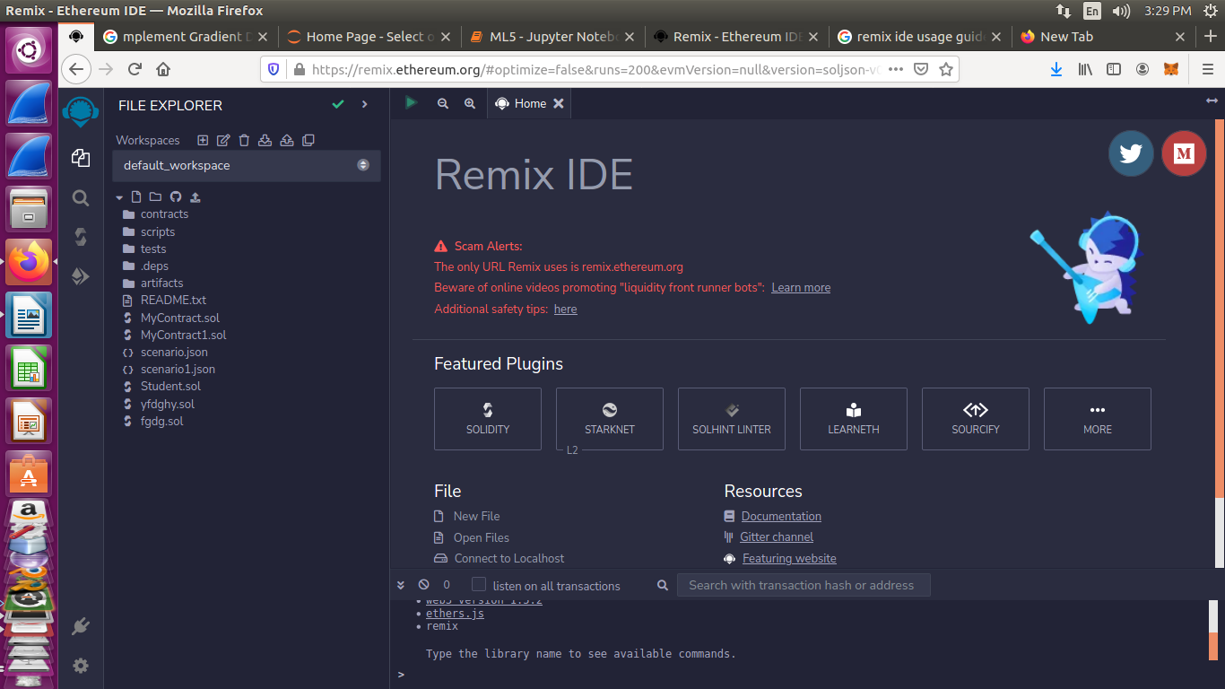

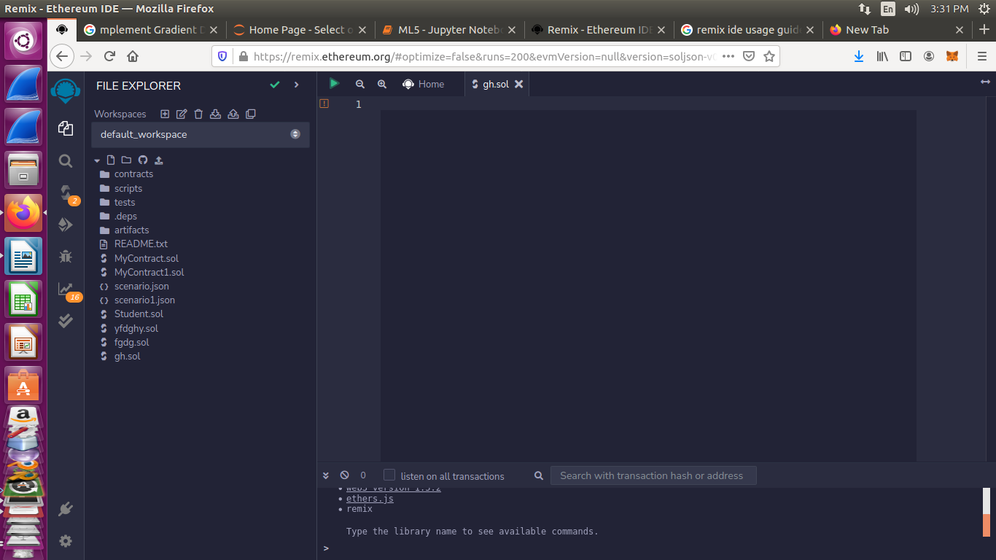

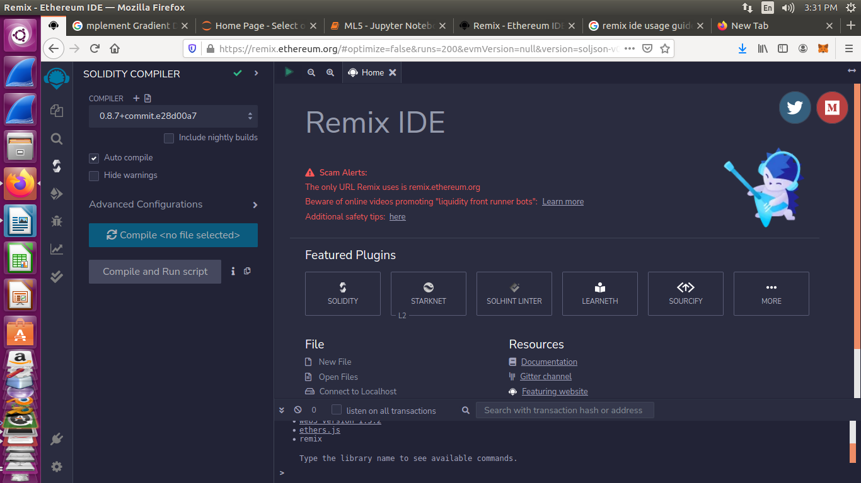

// Code

//SPDX-License-Identifier: Unlicensed

pragma solidity ^0.8.0;

contract Database{

struct student{

int ID;

string _fname;

string _lname;

}

int public Count = 0;

mapping(int => student) public stdRecords;

function addNew(int _id, string calldata _fname, string calldata _lname) public{

Count+=1;

stdRecords[Count] = student(_id, _fname, _lname);

}

event received(address user, uint amount);

receive() external payable{

emit received(msg.sender, msg.value);

}

}

